**How accurate are LCAs for pyrolysis and gasification in the context of plastic waste management?**

Tu Xayachaka, Nawshad Haqueb, Deborah Lauc, Raj Parthasarathya, Nargessadat Emamid, Biplob Kumar Pramanika*

a School of Engineering, RMIT University, VIC 3001, Australia.

b CSIRO Mineral Resources, Clayton South, Melbourne, VIC 3169, Australia.

cCSIRO Environment, Private Bag 10, Clayton South, VIC 3169, Australia.

d CSIRO Environment, Black Mountain Science & Innovation Park, Acton, ACT 2601, Australia.

*Corresponding author email: [biplob.pramanik@rmit.edu.au](mailto:biplob.pramanik@rmit.edu.au)

# Abstract

Pyrolysis and gasification are often presented in the life cycle assessment (LCA) literature as environmentally promising solutions for plastic waste management. However, the lack of validated large-scale inventory data and limited use of uncertainty/statistical analysis cast doubts on the findings. This study aims to investigate the validity of these conclusions by modelling LCA for pyrolysis (PYR) and gasification (GASI) using two data sources: Aspen-generated data (ASP) and aggregated literature data (LIT). The novelty of this study lies in applying uncertainty propagation tailored to each source, enabling systematic evaluation of result variability. Using a functional unit of 1 kg mixed polyolefin waste treated, our results show that Aspen-based scenarios exhibit narrower uncertainty ranges than their literature-based counterparts. For instance, the variability in terms of global warming potential for PYRO (ASP) ranged from 0.751 to 1.53 kg CO2 eq, whereas that of PYRO (LIT) ranged from 1.24 to 6.51. Similarly, GASI (ASP) had a more constrained 95% confidence interval (from 2.56 to 4.97 kg CO2 eq) compared to that of GASI (LIT), which spanned from 2.20 to 15.58 kg CO2 eq. This disparity largely stems from many underlying assumptions and simplification during Aspen modelling, leading to reduced number of variables. Conversely, literature-based LCA models are constrained by repeated reuse of data and by inconsistencies in system boundaries, which exacerbate result variability. Additionally, many LCAs omit important toxic emissions, such as PAHs, VOC, PFAS, and microplastics), which systematically resulted in underrepresentation of toxicity impacts. These issues suggest that the consensus in support of chemical recycling rests on a narrower data foundation than often assumed. As such, we recommend that LCA findings be used as policy reference only when supported by robust case-specific data, transparent uncertainty analysis, and explicit consideration of toxic emissions.

Keywords: LCA; chemical recycling; pyrolysis; gasification; plastic waste management; Monte Carlo

# Introduction

When plastic first entered mass-production in the 1950s, they were celebrated as revolutionary materials due to their inherent durability and versatility (Geyer, et al., 2017). Today, these same characteristics, coupled with plastic’s pervasiveness in everyday life, have led to an accumulation of waste that threatens the environment and human health. Unlike most other carbon-based waste streams, microbes cannot quickly decompose and return conventional polymers to the carbon cycle. Thus, plastic waste can persist in the environment for hundreds, if not thousands, of years. Moreover, the discovery of microplastic particles in the environment and their adverse effects on organisms add another layer of complexity to the plastic issue (Napper & Thompson, 2020). Over the past 20 years, global annual plastic production has doubled, reaching 400 million tonnes in 2022, while the global recycling rate stagnates at around 9% (Geyer, et al., 2017; OECD, 2022; Statista, 2024). Given these conditions, it may not be hyperbolic that many researchers are referring to the modern era as the “plastic age”, following the bronze and iron ages (Osborn & Stojkovic, 2014; Porta, 2021; Simon-Sánchez, et al., 2022). While reducing consumption is crucial to alleviate the effects of the “plastic age”, waste is inevitable. Therefore, recycling is warranted to maximise resource efficiency.

Presently, mechanical recycling is the predominant method for plastic waste recovery, but it often produces granulates with inferior value and utility due to the effects of downcycling (Davidson, et al., 2021). In response to these challenges, chemical recycling technologies have emerged as promising solutions. Chemical recycling is defined as processes that convert plastic waste to monomers or produce new raw materials by chemically altering the structure of plastic waste, though it is important to note that incineration and energy recovery are excluded from this definition (ISO, 2008; King, et al., 2021). While chemical recycling processes are generally more resource-intensive and less carbon-efficient compared to its mechanical counterpart, they offer a recovery option for waste streams that cannot be mechanically recycled, such as contaminated and hard-to-separate plastic waste (King, et al., 2021; Liang, et al., 2024). Depolymerisation is the most notable example of chemical recycling technologies due to its potential in converting PET plastics into their constituent monomers and oligomers (King & Locock, 2022). However, for olefin plastics, such as polypropylene (PE) and polypropylene (PP), pyrolysis and gasification are more suitable options. While these processes have great potentials, they also pose a number of environmental, safety and operational concerns due to their high energy demands, air emissions, low product yields, and extensive post-treatment requirements.

Many life cycle assessments (LCA) have been conducted to analyse the benefits and drawbacks of pyrolysis and gasification processes, with many studies hailing them as sustainable solutions to upcycle plastic waste and reduce their environmental impacts (Benavides, et al., 2017; Quantis, 2020; Keller, et al., 2020; Tomić, et al., 2022). Benavides et al. (2017) noted that fuels derived from plastic pyrolysis exhibited 58% and 96% lower water and fossil fuel consumption, respectively, compared to conventionally-produced diesel. Another study noted that gasification of plastic waste exhibited up to 91%, 24%, and 8% lower cumulative energy demand, global warming potential, and abiotic depletion potential, respectively, compared to incineration (Tomić, et al., 2022). Similarly positive results were reported by other LCA publications, including Gracida-Alvarez et al. (2019), Jeswani et al. (2021), and Voss et al. (2022). Despite these findings, the use of pyrolysis and gasification technologies is still a heavily debated topic as many overarching data and methodological concerns remain unaddressed by contemporary LCAs, prompting multiple critiques (Rollinson & Oladejo, 2019; Zero Waste Europe, 2020; Rollinson & Tangri, 2021; Bell, 2023; Bell, 2024; Nixon, et al., 2024).

LCA standards, namely ISO 14040 (ISO, 2006a) and ISO 14044 (ISO, 2006b), lack detailed guidance on several critical areas, especially pertaining to data quality considerations and statistical analysis, leaving ample room for interpretation (Weidema, 2014; Tascione, et al., 2024). Though this deliberate ambiguity allows greater flexibility, it can lead to inconsistency in LCA findings. Due to limited industry data, existing LCA studies for chemical recycling have relied on two main data collection/generation approaches: (i) using theoretical mass and energy balance models (often with Aspen or similar software) to derive inventory data (Gracida-Alvarez, et al., 2019; Zhao & You, 2020; Olafasakin, et al., 2023; Keller, et al., 2020; Chari, et al., 2023); and (ii) aggregating data from lab-scale experiments, existing LCAs, and/or macro research publications (Perugini, et al., 2005; Iribarren, et al., 2012; Tomić, et al., 2022; Das, et al., 2022; Xayachak, et al., 2023). Regardless of how inventory data was developed, a number of glaring flaws remains pervasive in this area. Zero Waste Europe (2020) noted that many LCA studies for chemical recycling contain a multitude of questionable data choices, with extrapolated, unverifiable, and untested data/assumptions being highly prevalent. Rollinson & Tangri (2021) echoed these sentiments in their rebuttal to Benavides et al. (2017), citing the lack of statistical analysis, limited data disclosure, and claims of no external energy requirement as the main criticisms. Given these constraints, Rollinson & Oladejo (2019) described ‘net-positive-energy’ pyrolysis as “thermodynamically unproven” and Bell et al. (2023) even called for a complete abandonment of chemical recycling projects. Indeed, chemical recycling processes are notoriously erratic due to the variety of process configuration (e.g., reactor types, operating temperature, gasifying agents, catalyst, steam-to-feedstock ratio, etc.) and constant changes in feedstock compositions, leading to inconsistent environmental performance. However, this dynamism is scarcely reflected in LCAs, with many studies presenting static and unidimensional results. While past critiques have directed much-needed attention to the glaring issues in LCAs for chemical recycling, they can be reductive and offer limited values in addressing the existing deficiency. Building on a comparative LCA case study that applies two approaches to inventory data collection/generation, one from Aspen modelling and another using aggregated literature sources, this paper examines how data origin influences variability in LCA results for pyrolysis and gasification. However, unlike other LCA publications in this area, the focal point of this study is not the quantification of environmental impacts, but to use this analysis as a basis to provide contextualisation and enable a deeper discussion pertaining to the uncertainty and variability of LCA results. As such, the novelty of this study lies in its application of uncertainty propagation methods specific to each data gathering approach, as well as in its critical examination of the role of LCA as a policy reference for decision-making in chemical recycling and sustainable plastic waste management.

# Methodology

## Goal and Scope Definition

This study aims to develop LCA models for pyrolysis (PYRO) and steam gasification for hydrogen production (GASI) in the context of plastic waste management. The primary objective is to quantify the uncertainty of LCA results arise from different LCA data collection methods. For each technology, LCA analyses were conducted twice, once using mass and energy balance data generated from Aspen Plus simulation (ASP), and another using aggregated literature data (LIT). This dual approach allows us to assess the environmental impacts of these chemical processes while improving the depth of analysis and facilitate further discussions regarding data quality and result variability in LCA. Thus, four scenarios, namely PYRO (ASP), PYRO (LIT), GASI (ASP), GASI (LIT) are presented in this study, each operates within a dedicated conceptual plant consisting of pre-treatment stage (e.g., grinder and washer), main conversion (e.g., gasifier and pyrolysis reactor), and post-treatment processing (e.g., hydrocracking, steam-methane reformer, and water-gas-shift reactors) (Fig. 1).

This study adopts a functional unit of ‘1 kg mixed polyolefin (MPO) waste treated’. The daily operating capacity for the pyrolysis and gasification plants is set at 275 and 150 tonnes MPO treated, respectively. The system boundary begins with the delivery of burden-free MPO to the gate of the plant and ends when the product(s) are supplied to the market (see Fig. 1). Impacts associated with material recovery facilities, such as sorting, collection, and transportation were excluded. Our analysis includes the direct air, water, and land emissions from each scenario, as well as their indirect impacts from background activities, such as energy and material production. Environmental impacts related to plant startups (e.g., purging and pressurisation) were excluded as their influences on the plant’s overall impacts were deemed minimal. Some material uses, such as refrigerants and cooling water, were also omitted because they are continuously recycled within the plant, though electricity consumption of cold boxes were considered in the analysis. Lastly, due to limited research and data, the impacts of microplastic generated during pyrolysis and gasification were not considered.

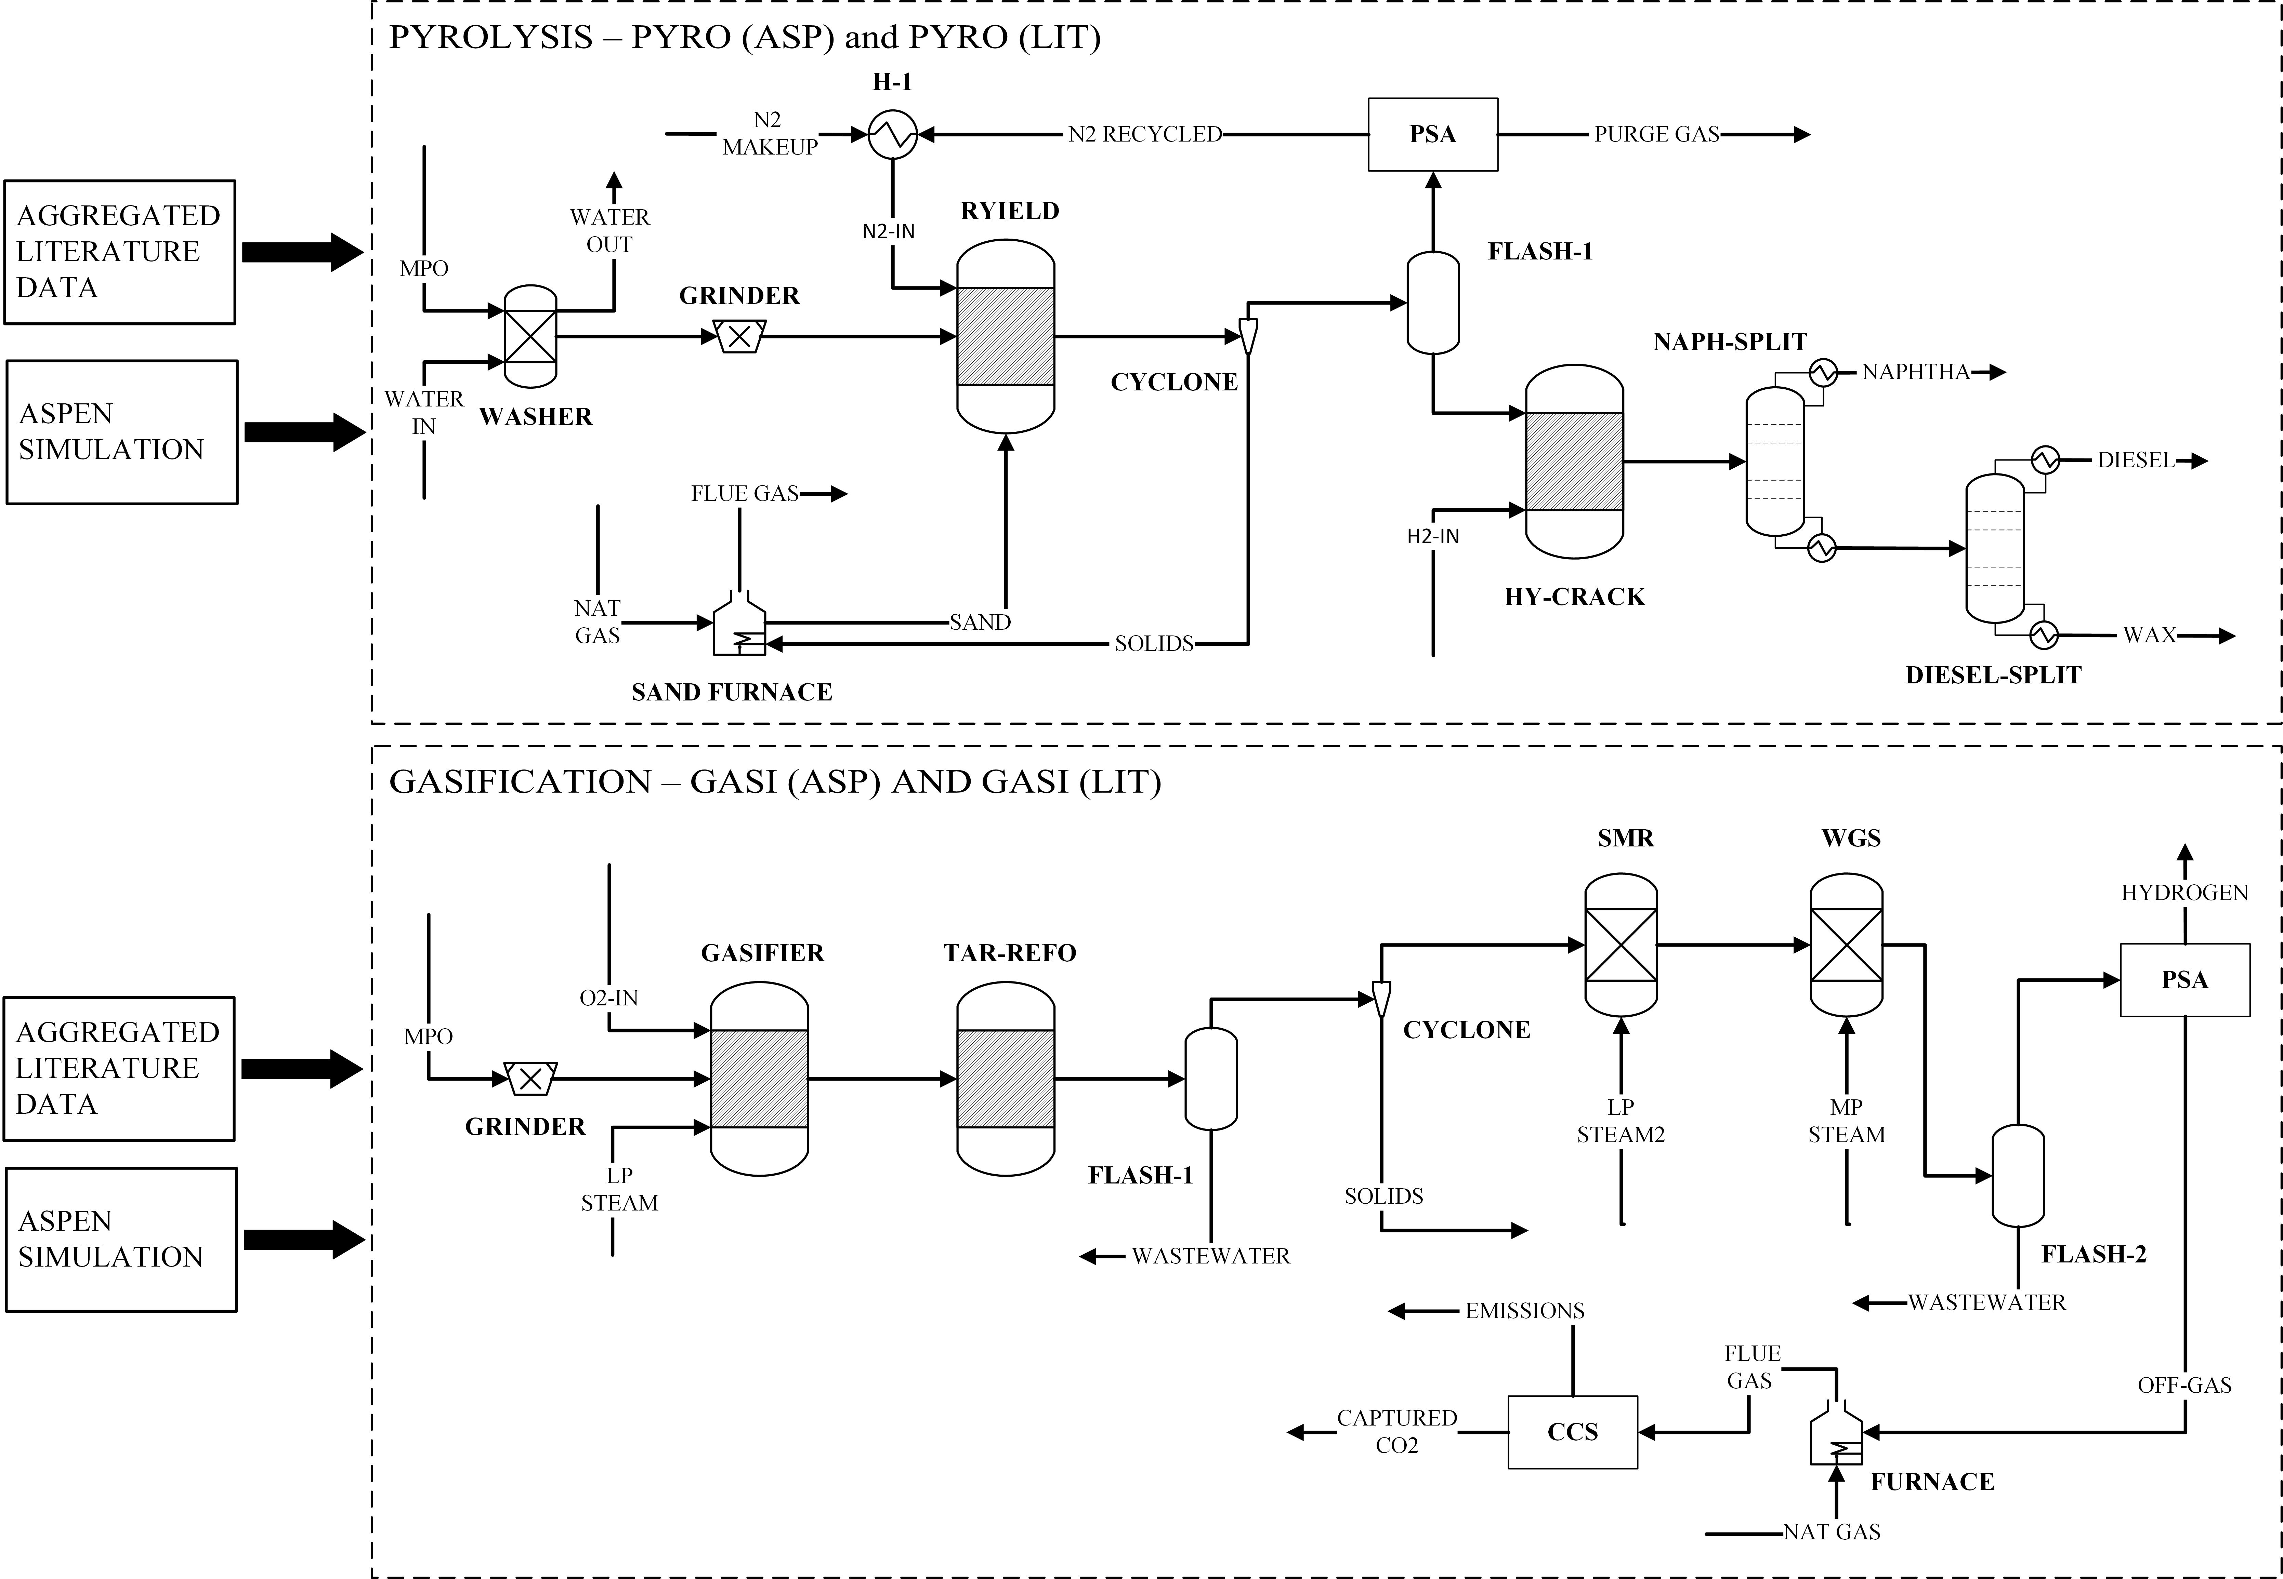

**Fig. 1 | Simplified process flow diagram and system boundaries for scenarios analysed in this work.**

## Life Cycle Inventory

This study uses a variety of sources to develop comprehensive inventory data from which analyses can be conducted. Background data, such as electricity production, treatment of solid waste and wastewater, and elementary flows were collected from Ecoinvent V3.11. Australia-specific data were prioritised, if these data were unavailable, global datasets were used as proxies. Supplementary Table 1 lists the specific Ecoinvent datasets used in this study. Emulating the approach adopted by many LCA studies in the literature, the parametrical inputs for foreground systems (e.g., direct energy and material consumption, direct air emissions, wastewater, and solid waste generation) were sourced from either Aspen Plus simulation or aggregated literature data. Additionally, due to limited data and lack of research, it was necessary to draw equivalency between pyrolysis- and gasification-specific flows and Ecoinvent flows. For example, the management of solid waste generated by gasification was assumed to carry the same impact as the flow “Process specific burden, residual material landfill” in Ecoinvent. Data were collected as detailed as practically possible, excluding black-box datasets that only contained facility-level inputs and outputs, and prioritising equipment-specific information (e.g., reactor duty, steam inputs for steam-methane reactor, and hydrogen input for hydrocracking). Inventory data used in this study are available in Supplementary Tables 2 to 5.

### Simulated Data

Aspen Plus V12.1 was used for process simulations and generating inventory data for ASP scenarios. MPO feedstock was modelled as a group of non-conventional components consisting of 50% high density polyethylene (HDPE) and 50% polypropylene (PP). Physical properties of HDPE and PP were obtained from Aspen Plus Database while their proximate and ultimate composition were averaged from various studies (Meys, et al., 2020; Jaafar, et al., 2022; Lan & Yao, 2022). It is important to note that the choice of this rather idealised feedstock, which contains no contamination and other polymer types, were deliberate as it allows us to analyse result uncertainty under controlled and simplified conditions. Additionally, this feedstock mix is also suitable for both pyrolysis and gasification technologies, providing equivalent basis for further comparisons (Civancik-Uslu, et al., 2021; Al-Qadri, et al., 2022; Olafasakin, et al., 2023). The characteristics of MPO feedstock are summarised in Supplementary 6.

The simplified process flow diagram for PYRO (ASP) and GASI (ASP) is presented in Fig. 1. In PYRO (ASP), the MPO is pre-treated by a counter-current washer, a hammer mill, and a dryer. Following pre-treatment, the feedstock enters the pyrolysis reactor, whose modelling was simulated as an RYIELD unit on Aspen Plus. The pyroliser was modelled as fluidised bed reactor operated at 500°C, with sand acting as a bedding material and pure nitrogen being the fluidising gas. Raw product yield was based on various lab-scale studies, including Predel & Kaminsky (2000), Singh et al. (2019), and Fraczak et al. (2021). The raw product exits the reactor and enters a gas-solid separation unit, where sand and pyrolysis char are removed from the flowing gas and diverted to a CHP unit. Here, char is combusted with external natural gas to provide heat for the reactor in the form of heated sand, similar to modelling used in Gracida-Alvarez et al. (2019). The flowing gas is separated by a flash separator, with the top product being sent to a condenser and a pressure swing adsorber (PSA) for pyrolysis gas refinement and nitrogen recovery. The bottom product from the flash separator is directed to a hydrocracking unit, where pyrolysis oil is upgraded into refined hydrocarbon products, particularly naphtha, wax, and diesel. External hydrogen gas was used for hydrocracking. Due to the large number of thermochemical reactions taking place during pyrolysis, a “lumping” strategy, which involves grouping chemical compounds with similar reactivity into a single representative species, was employed to minimise computational requirements of the analysis (Dogu, et al., 2021).

In this study, GASI (ASP) was modelled specifically for hydrogen gas production using. MPO feedstock undergoes size reduction in a hammermill before being sent to gasification reactors. Consistent with previous studies, gasification was modelled as a two-stage process, including a main gasification reactor followed by a tar reforming unit, which is essential for large-scale hydrogen production (Cho, et al., 2014). A fixed-bed reactor was used to model the main gasifier. The reactor utilises autothermal heating in which reaction energy is generated via partial oxidation with high-purity oxygen and low-pressure (LP) steam acting as gasification agents, similar to models developed by Keller et al. (2022b), Lan & Yao (2022), and Afzal et al. (2023). The gasifier operates at 850°C and 1 bar, with steam-to-plastic and oxygen-to-plastic ratios of 2.0 and 0.65 (mass basis), respectively (Chari, et al., 2023; Afzal, et al., 2023).

Based on previous publications (Lan & Yao, 2022; Chari, et al., 2023), gasification was represented by RStoic and RGibbs reactors in Aspen Plus. The former converts MPO feedstock into its atomic constituents, which allows RGibbs to estimate the syngas composition (Tungalag, et al., 2020; Lan & Yao, 2022). Seven reactions were considered in RGibbs, which are presented in Supplementary Table 7. The tar reforming unit was added to reduce the hydrocarbon contents of the raw syngas and promote H2 and CO contents. Tar reformer was modelled as a fixed-bed reactor, operating at 890°C and 1 bar; its conversion data were taken from (Phillips, et al., 2007). Following gasification and tar reformation, the raw syngas is separated from water condensate by a flash separator, then treated in a steam-methane reformer (SMR) to converts methane into H2 and CO contents, with a 94% conversion rate (Afzal, et al., 2023). The syngas mixture is then compressed to 20 bar and directed to a water-gas-shift reactor, where medium-pressure (MP) steam reactors with carbon monoxide to produce CO2 and H2, with 90% conversion rate at 380°C. Hydrogen gas is refined and collected by a PSA unit while the off-gas is directed to a CHP unit. Supplemented by external natural gas, the furnace combusts the off-gas to produce heat and steam for the entire plant. A carbon capture and storage unit (CCS) was used to capture the flue gas generated by the furnace.

Key modelling results, assumptions, and simplifications for Aspen Plus simulation are summarised in Table 1. It is important to note that some processes, such as PSA and CCS, were not directly modelled in Aspen Plus. Instead, their impacts are reflected using key performance indicators (KPI), such as electricity usage and recovery efficiency, using information from similar processes found in the literature (Ribeiro, et al., 2013; Song, et al., 2015; Jackson & Brodal, 2019) (see Supplementary Table 8). Detailed process flow diagram for PYRO (ASP) and GASI (ASP) are presented in Supplementary Information 1 and 2, respectively. Details regarding operating conditions and the property methods for major components and equipment are provided in Supplementary Tables 9 and 10, respectively. The stream table from the Aspen process simulations for PYRO (ASP) and GASI (ASP) are presented in Supplementary Table 11 and 12, respectively.

Tab. 1 | Summary of Aspen modelling results and parameters. A detailed version of this table is available in Supplementary Table 8 to 12.

|  |  |  |
| --- | --- | --- |
| **Parameter** | **Pyrolysis** | **Gasification** |
| Feed rate | 275 tonne/day | 150 tonne/day |
| MPO composition | 50% PE; 50% PP | |
| Reactor temperature/pressure | 500°C; 1 bar | 850°C; 1 bar |
| Reactor type | Fluidised bed | Fixed bed |
| Heating type | Heat carrier (sand) | Autothermal |
| Gasifying agent | N/A | Steam: 300 tonne/day  O2: 98.49 tonne/day |
| Solid residue | 11.95 tonne/day | 3.32 tonne/day |
| External natural gas input | 6.48 tonne/day | 58.49 tonne/day |
| H2-CO ratio | N/A | 2.1 |
| H2 to HY-CRACK | 0.884 m3/ kg liquid | N/A |
| Steam-to-gas mass ratio in SMR | N/A | 1.3 |
| Steam-to-gas mass ratio in WGS | N/A | 1.25 |
| Product per kg MPO | Naphtha: 0.770 kg | H2: 0.298 kg |
| PSA electricity consumption | 6,036 MJ/tonne H2 | 1,502 MJ/tonne N2 |
| CCS electricity consumption | N/A | 359.4 MJ/tonne CO2 |
| Heat loss in furnace | 1.5% LHV of LNG | |
| General heat loss in reactors | 10% | |

### Aggregated Literature Data

Aggregated literature data were collected from relevant peer-reviewed publications using the Preferred Reporting Items for Systematic Reviews and Meta-Analyses (PRISMA) method (Supplementary Information 3). The search was conducted within the Web of Science and Scopus databases, utilising a specifically craft search string featuring keywords such as “life-cycle assessment”, “sustainability assessment”, “plastic waste” and “chemical recycling” (see Supplementary Information 4 for complete search string). The search results were preliminarily screened using a custom Python script to remove duplicated studies and studies not available in English. The remaining publications were thoroughly screen and those that did not meet the inclusion criteria (presented in Supplementary Table 13) were excluded. In total, 67 studies were collected. To ensure consistency in system boundary with the Aspen-based scenarios, only data points directly attributable to the equipment shown in Fig. 1 were included in the final inventory. As a results, only 22 of the collected studies were used to generate inventory data for the LIT scenarios. Nonetheless, the remaining studies were retained as they can be particularly useful in result comparison. A summary of all studies is presented in Supplementary Tables 14 and 15. Additionally, a summary of lab-scale pyrolysis and gasification studies is presented in Supplementary Tables 16 to 18.

## Life Cycle Impact Assessment

OpenLCA V2.1.1 was used to tabulate input and output information and conduct life cycle impact assessments (LCIA). Latest version of LCIA methods recommended by ILCD (JRC, 2011) were used, focusing on key midpoint impact categories, including global warming potential (GWP), acidification (AP), freshwater eutrophication (FWE), freshwater ecotoxicity (FWETP), and resource depletion, mineral, fossil, and renewable (RD). Supplementary Table 19 shows a summary of all impact categories under ILCD framework as well as their corresponding LCIA method. Mass and energy flows that contribute less than 1% to the total system flow were omitted, though the sum of all neglected flows did not exceed 5%. No normalisation and weighting were performed as part of this analysis. Additionally, as this study focuses on result variability and data quality considerations, rather than the actual environmental performance of pyrolysis and gasification, no allocation or product substitution was applied during LCA modelling. In other words, the inputs and emissions for each scenario were not allocated to the products and by-product generated. Similarly, credits for “avoided” landfill/incinerator impacts were not considered in the analysis. Further discussion on this topic is provided in Section 4.

## Uncertainty Propagation

Uncertainty analysis is a critical component of this study as it addresses the inherent result variability and enhances the robustness of our findings. This study uses a stochastic approach for uncertainty propagation. In the case presented below, we assumed that all data-related uncertainties can be represented by lognormal distributions, which is commonly used to represent non-negative and positively skewed data points found in LCA (Weidema & Wesnaes, 1996). In lognormal distributions, the square of the geometric standard deviation () covers 95% of the confidence interval and is often used as a quantitative indicator of uncertainty for a given parameter (Bisinella, et al., 2016).

In this study, was calculated as a function of basic and additional uncertainty factors (Equation 1 and 2). Basic uncertainty factors (*Ub*) represent uncertainties associated with measurement errors and normal data fluctuations. For example, the basic uncertainty factor for CO2 emission data (*Ub* = 1.05) is lower than that of heavy metal emission (*Ub* = 3) because CO2 measurements are generally more precise and can be easily validated against the fuel inputs. In our investigation, *Ub* value for each parameter was based on expert estimations provided by PRé Sustainability (2016). Uniquely, given that two distinct data sources were used in LCA modelling – Aspen simulated data and aggregated literature data – we applied two types of additional uncertainty factors, namely classical uncertainty factors (*Ua,c*) and sampling uncertainty factors (*Ua,s*).

For Aspen simulated data, *Ua,c* was determined using the Pedigree matrix (Equation 3). This approach accounts for five uncertainty criteria, including data reliability, completeness, temporal correlation, geographical correlation, and other technological correlation (Frischknecht, et al., 2005). Each criterion was given a score based on our assessment, which was then used to calculate its corresponding uncertainty factor (Frischknecht, et al., 2005). In contrast, for analyses that used aggregated literature data, all available data points of a given parameter (e.g., market for oxygen) were sampled to calculate the geometric standard deviation, which served as the sampling uncertainty factor (*Ua,s)* for that parameter. For parameters that only have one data point, *Ua,s*value of 1 was assumed.

The final uncertainty factor for each parameter () was used to generate an uncertainty distribution. Hence, data uncertainties were methodically propagated into result uncertainties using Monte Carlo analysis, during which multiple analysis iterations were performed to simulate a range of possible outcomes, thereby providing a probabilistic distribution of the LCA results. In this study, Monte Carlo analysis was repeated for 10,000 runs for each scenario. The resulting impact scores were analysed by creating error bar charts, probability histograms, and cumulative frequency histograms to reflect the uncertainty of the LCA results. To improve the legibility of these figures, extreme outliers were excluded. No more than 50 outliers were removed for each result.

Where represents the final uncertainty; Ub is the basic uncertainty factor; *Ua,s* represents additional uncertainty factor calculated by statistical sampling; and *Ua,c* represents classical additional uncertainty factor, which was determined using the pedigree matrix; , , , , and represent pedigree matrix scores in data reliability, data completeness, temporal correlation, geographical correlation, and further technological correlation, respectively.

# Results

## Characterised Impacts

The characterised impact scores of all chemical recycling scenarios are presented in Fig. 2 for selected impact categories based on a functional unit of 1 kg MPO waste treated. Our LCA results indicate that gasification scenarios generally perform worse than their pyrolysis counterparts. For instance, GASI (LIT) exhibits the highest GWP and AP impacts (3.06 kg CO2 eq and 0.012 mole H+ eq, respectively), followed very closely by GASI (ASP) (3.05 kg CO2 eq and 0.011 mole H+ eq, respectively). GASI (ASP) shows the greatest impacts in FWE and FWETP, at 0.00298 kg P eq and 29.8 CTUe, respectively. RD observed the most significant impact from GASI (LIT), at 1.27E-5 kg Sb eq. In all impact categories, market for electricity and market for oxygen emerged as major drivers of impacts for gasification scenarios. Additionally, GASI (ASP) observed noticeable contributions from natural gas production whereas steam production considerably influences GASI (LIT)’s impact score. The distinction between these scenarios stems from differences in modelling approaches. Existing LCAs for gasification used the steam production dataset from Ecoinvent to represent the impacts of steam input. Conversely, GASI (ASP) represents steam inputs as water use combined with the energy demand, in the form of natural gas, to convert water into steam. The enormity of gasification impacts, especially in comparison to pyrolysis scenarios, are not unexpected as gasification scenarios are known to require high operating temperatures (>750°C), large amounts of high-purity gas, and superheated steam to produce syngas suitable for hydrogen production (King, et al., 2021; Keller, et al., 2022b). Further, ancillary processes for syngas refinement, such SMR, WGS, PSA, and CCS units, add to gasification’s poor environmental performance (Volkart, et al., 2013; Ribeiro, et al., 2013; Song, et al., 2015; Jackson & Brodal, 2019). Theoretically, air could be used in lieu of pure oxygen to minimise the impacts of market for oxygen, but this will lead to nitrogen-diluted syngas, which is only suitable for energy recovery (Keller, et al., 2022b). Similarly, allothermal gasification can negate impacts from oxygen demands, but external energy is needed for gasification reactions to occur. This energy can be provided by heating the reactor surfaces or heat-carrying bed materials (e.g., sand and olivine), which can be periodically heated in a separate furnace (Keller, et al., 2022b; Lan & Yao, 2022). It is also important to note that while the hydrogen gas produced by gasification is generally more valuable than pyrolysis products (i.e., naphtha), its value was not reflected in the final LCA results due to our deliberate choice of excluding “avoided impacts”.

Amongst all scenarios, PYRO (ASP) exhibits the lowest environmental impacts across all categories, with GWP, AP, FWE, RD, and FWETP impact score of 0.88538 kg CO2 eq, 0.0026 mole H+ eq, 0.0009 kg P eq, 1.5E-6 kg Sb eq, and 7.6 CTUe, respectively. The most prominent contributors for this scenario are market for electricity (for GWP, AP, FWE, and FWETP) and market for hydrogen (RD). Similarly, PYRO (LIT)’s impacts in most categories (except for RD) are primarily driven by market for electricity. A notable difference between PYRO (LIT) and PYRO (ASP) can be observed in Fig. 2d, with zeolite production overwhelmingly contributes to PYRO (LIT)’s total impacts in RD category. PYRO (LIT) also exhibits higher electricity consumption, leading to an overall increase in environmental impacts compared to its Aspen-based counterparts. No discernible trend is observed when comparing Aspen- and literature-based data. More specifically, PYRO (ASP) exhibits lower environmental impacts compared to PYRO (LIT). Conversely, GASI (ASP) records higher impact scores in GASI (LIT) in FWE and FWETP, whereas the reverse is observed for RD category. Additional impact scores for all categories are available in Supplementary Table 20.

A comparison between our GWP impact scores and those from the literature was made to validate our findings and provide a strong foundation for further discussion (see Fig. 3). With the exception of PYRO (ASP), our results are generally higher than most existing LCAs, possibly due to Australia’s electricity mix being more heavily reliant on fossil fuels than the global average, resulting in higher indirect CO2 burden (Ritchie & Rosado, 2020; Australian Energy Update, 2023). Thus, it is possible that these impacts will gradually reduce as Australia transition to more sustainable energy sources for electricity production.

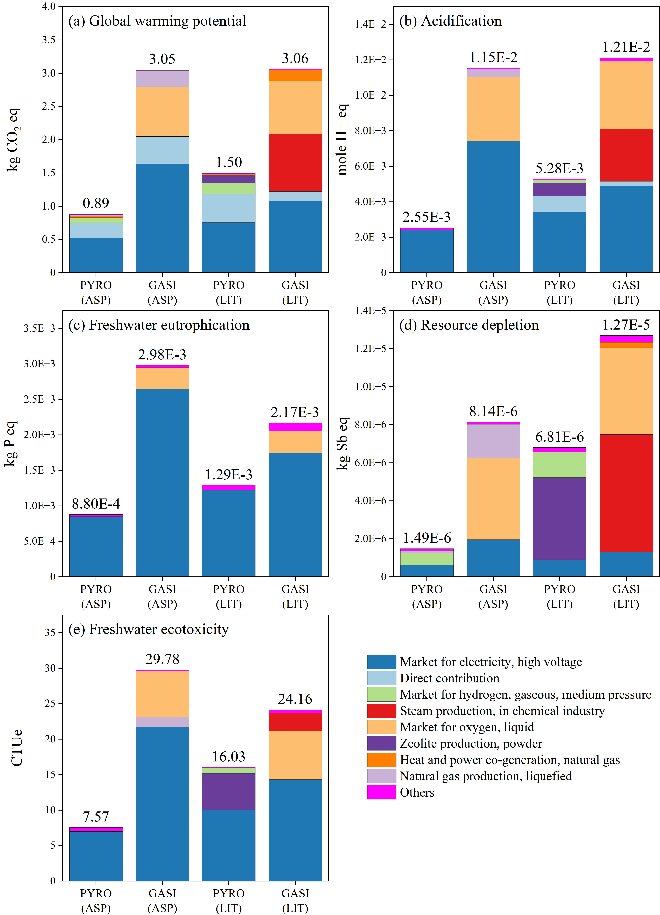

**Fig. 2 | LCIA results for five key impact categories.** Based on a functional unit of 1 kg polyolefin waste treated. PYRO: pyrolysis; GASI: gasification; ASP: Aspen-simulated data; LIT: aggregated literature data. No allocation/crediting applied. Value atop each column represents total impact score.

**Fig. 3 |** GWP impact scores of this work compared to selected studies from the literature. Values normalised to 1 kg waste treated. No allocation/crediting applied. * Only chemical recycling and hydrocracking included.

## Monte Carlo

Results from Monte Carlo simulations for selected impact categories are summarised as error bar charts in Fig. 4, showing original impact scores (i.e., calculated values) as well as the propagated means, medians, and the 95% confidence interval of result variability. To enhance the quality of discussion hereafter and provide crucial comparative perspective, we replicated Monte Carlo simulations using inventory data and values published by Tomić et al. (2022). The replicated Monte Carlo analysis results, designated as PYRO (REP) and GASI (REP), are presented alongside findings from this study in Fig. 5 as probability histograms. Additionally, a cumulative frequency histogram is presented in Fig. 6. The complete Monte Carlo results for all scenarios and impact categories are presented in Supplementary Table 21 to 26.

Uncertainty propagation with 10,000 iterations of Monte Carlo simulation indicates varied result ranges for different scenarios across all impact categories, with Aspen-based scenarios exhibiting narrower confidence intervals and higher relative frequency compared to their literature-based counterparts. For example, the 95% confidence interval for PYRO (ASP) ranges from 0.751 to 1.53 kg CO2 eq, peaking at ≈ 0.95 kg CO2 eq (f/n ≈ 0.19). This uncertainty range is relatively narrow compared to PYRO (LIT), whose GWP impact scores span from 1.24 to 6.51 kg CO2 eq, peaking at ≈ 1.55 kg CO2 eq (f/n ≈ 0.064). Similarly, GASI (ASP)’s confidence interval (from 2.56 to 4.97 kg CO2 eq) is considerably more constrained compared to that of GASI (LIT) (from 2.20 to 15.58 kg CO2 eq). The discrepancy between ASP and LIT scenarios is also reflected in the cumulative relative frequency curve (c.f.) in Fig. 6, which shows PYRO (LIT) and GASI (LIT) exhibiting rather gradual rise, only reaching c.f. ≈ 1 at approximately 8.0 and 27.0 kg CO2 eq, respectively. While this trend is particularly evident for GWP, similar observations can be made for all impact categories (Fig. 4).

The inconsistency between ASP and LIT scenarios may stem from the inherent differences in data collection/generation approaches. LCA modelling using literature-cited inventory data may contain information that varies wildly due to numerous factors, such as different measuring and reporting scopes/methods. For example, PYRO (LIT) demonstrates the highest level of result variability in AP category (Fig. 4b) compared to other scenarios, from 3.1E-3 to 4.5E-2 mole H+ eq. This rather large uncertainty stems from the enormous discrepancy in direct SO2 emissions – a key contributor acidification – reported by existing LCAs. More specifically, this parameter was reported as 3.23E-6 and 3.36E-6 kg SO2 eq by Viveros et al. (2022) and Khoo (2019), respectively, whereas Perugini et al. (2005) reported a value of 2.0E-3 kg SO2 eq, representing a difference of three orders of magnitude and resulting in value of up to 41.4. Similar level of disparity can be observed for direct VOC emissions from pyrolysis reported by Zhang et al. (2021), Khoo (2019), and RTI Internationals (2012); and gasifier heat requirement reported by Chari et al. (2023), Al-Qadri et al. (2022), and Keller et al. (2022a).

Although ASP scenarios may appear to exhibit lower uncertainty, this finding should be interpreted with caution. Aspen-generated data can be more case specific and better aligned with the scope of analysis, but they rely on considerable assumptions and extrapolations, such as simplified process flows, static and favourable operating conditions, and uncontaminated feedstock (Gracida-Alvarez, et al., 2019; Olafasakin, et al., 2023; Yadav, et al., 2023). These limitations inevitably omit certain flows; for example, assuming a PVC-free feedstock excludes HCl emissions, leading to underestimated impacts and omitted uncertainty, thereby reducing result variability.

A peculiar feature can be seen for FWETP category (Fig. 4e), wherein the calculated values fall very close to or below the 5th percentile. More specifically, the calculated FWETP score and 5th percentile were respectively found to be 7.57 and 8.38 CTUe for PYRO (ASP), 29.8 and 32.8 CTUe for GASI (ASP), 16.0 and 16.8 CTUe for PYRO (LIT), and 24.2 and 20.4 CTUe for GASI (LIT). Similar results were obtained after multiple re-runs of Monte Carlo simulations, prompting several speculations. Most probably, due to the wide range of fate and effect factors of different pollutants, the selection of a common midpoint toxicity impact can be somewhat arbitrary (Hauschild, et al., 2013). As such, inherent uncertainties associated with toxicity categories (e.g., human toxicity and freshwater/marine/terrestrial ecotoxicity) are considerably higher than those of other impact categories (JRC, 2011; Renouf, et al., 2015). Additionally, the high variability in FWETP may stem from the cumulative influence of outliers in the inventory data. These outliers likely reflect the high basic uncertainty factor (*Ub*) of background (Ecoinvent) and foreground flows that strongly contribute to toxicity impacts (e.g., heavy metal emissions) (PRé Sustainability, 2016). Additionally, due to limited data and the generalisation of our model, toxic emissions, such as PAHs, VOCs, particulate matter, and heavy metals were not included (Valavanidis, et al., 2008; Sahle-Demessie, et al., 2021). It is reasonable to expect that a more detailed and realistic LCA model would result in considerably higher uncertainty in toxicity impact categories.

Comparing our Monte Carlo results for GWP with those replicated using data from Tomić et al. (2022) yielded notable insights (Fig. 5). For pyrolysis, PYRO (ASP) exhibited a rather limited result distribution (peak ≈ 0.95 kg CO2 eq; f/n ≈ 0.19) compated to its replicated counterpart (peak ≈ 1.15 kg CO2 eq; f/n ≈ 0.095). On the other hand, PYRO (LIT) shows more similarities with PYRO (REP), differing only by a slightly broader result distribution (peak ≈ 1.55 kg CO2 eq; f/n ≈ 0.064). Gasification indicate more pronounced distinction amongst ASP, LIT, and REP scenarios. More specifically, GASI (REP) demonstrates a large range of result distribution, reaching peak frequency of only ≈ 0.023 at 8.3 kg CO2 eq. Conversely, GASI (ASP) has considerably narrower result distributions, peaking at ≈ 3.3 kg CO2 eq (f/n ≈ 0.12). With a peak frequency of ≈ 0.068 at ≈ 2.9 kg CO2 eq, GASI (LIT)’s result distribution is less variable than GASI (REP), but not as consistent as GASI (ASP). Despite the massive result variability in GASI (REP), which can also be seen in the original publication, discussions regarding this variability and its influences on result reliability have been largely absent. It should be emphasised that this is not a unique case but a rather common theme across the litearture, as discussed in the following section.

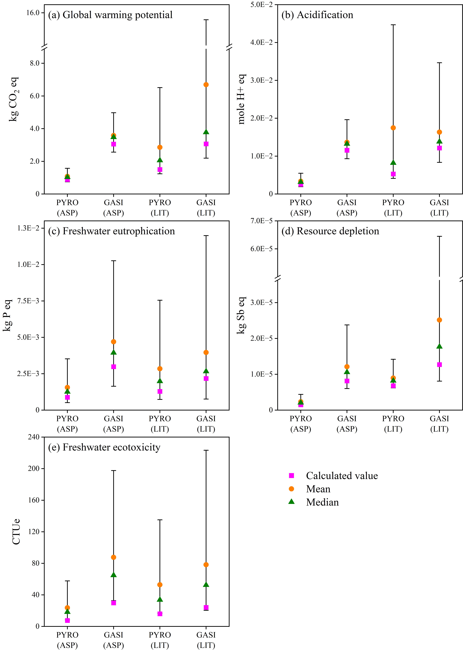

**Fig. 4 | Monte Carlo simulation results for five key impact categories, showing the initially calculated LCIA results (i.e., calculated values), as well as propagated means, medians, and the 95% confidence interval.**

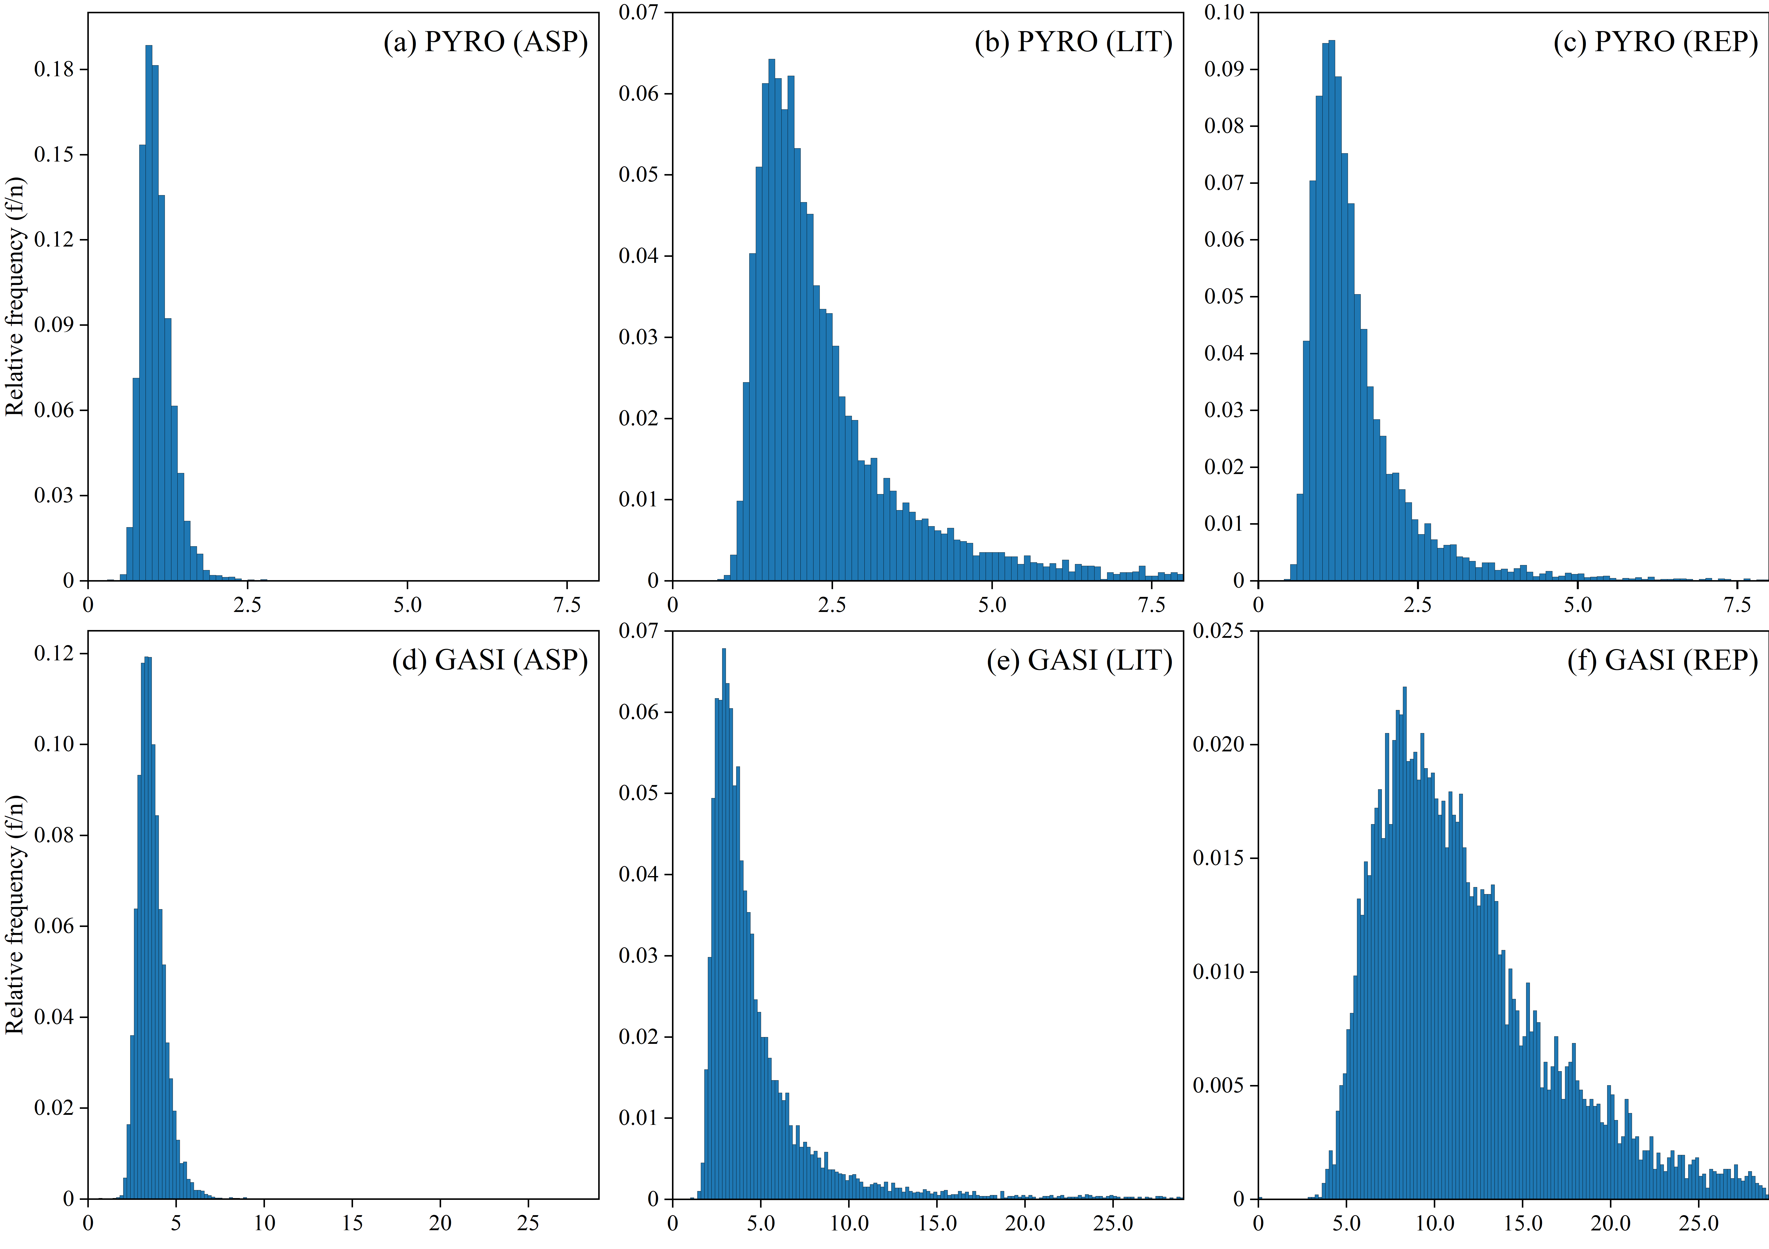

**Fig. 5 | Probability histogram for GWP (unit: kg CO2 eq/kg MPO treated).**

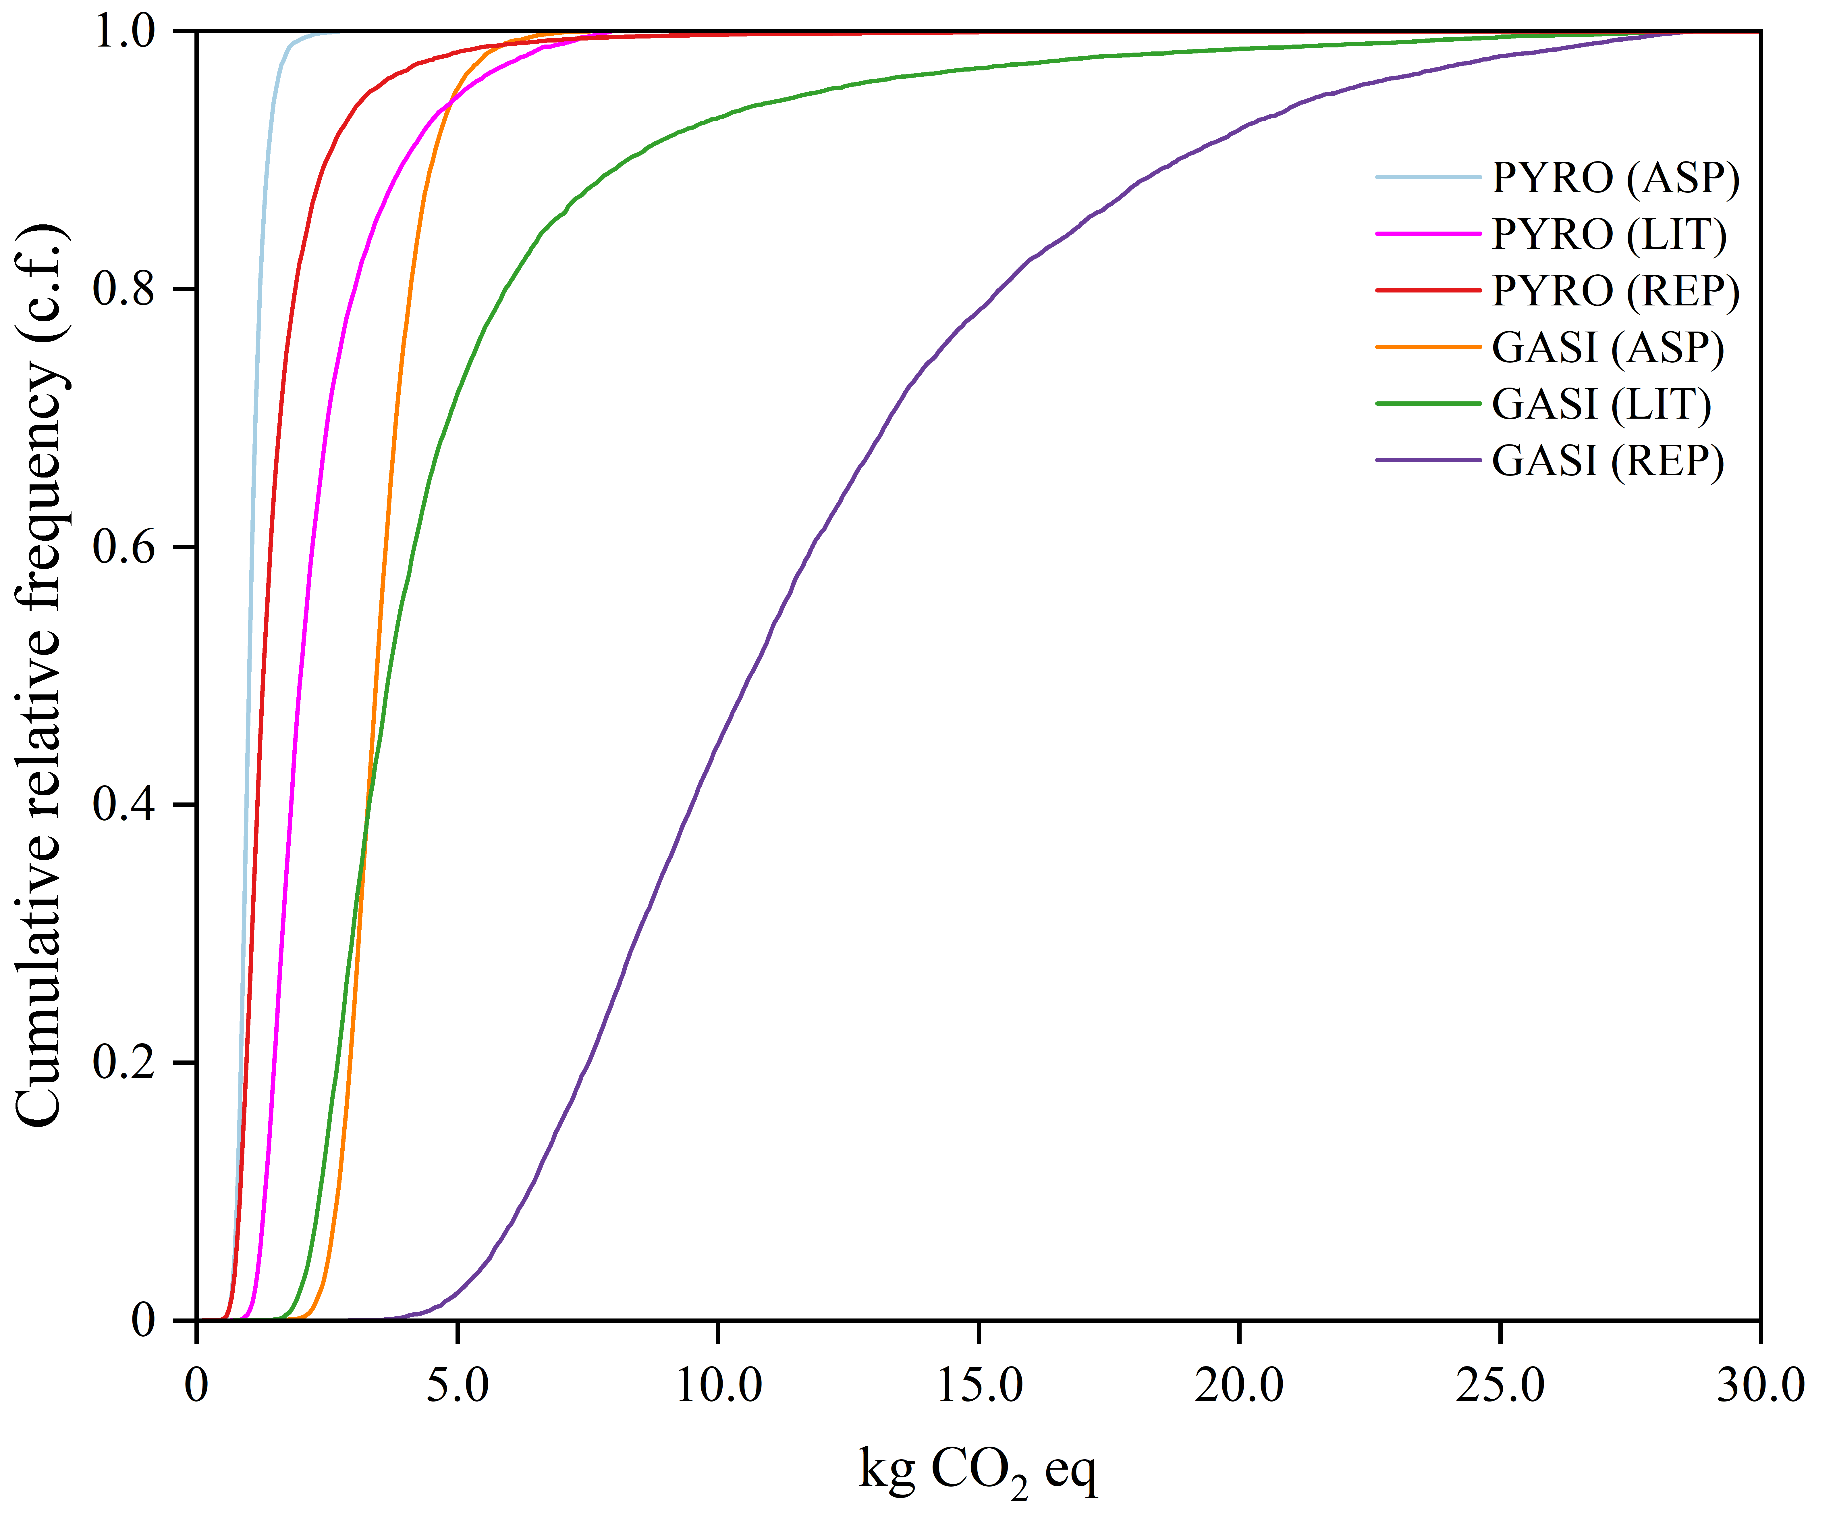

**Fig. 6 | Cumulative relative frequency histogram for GWP (unit kg CO2 eq).**

# Discussions

Drawing from our experience with LCA models developed from two data sources, this section critically examines the limitation of each approach. A major challenge in LCAs for chemical recycling is the limited availability of commercial-scale data. While several studies claimed to use inventory data from commercial technology providers/operators (Benavides, et al., 2017; Jeswani, et al., 2021), such data were either unpublished or heavily redacted. This has raised legitimate concerns regarding data validation and result reproducibility (Rollinson & Tangri, 2021). In the absence of primary inventory flows, prospective LCAs have typically relied on two data sources: mathematical models (e.g., Aspen modelling) and aggregated literary data.

Mathematical modelling provides a case-specific material and energy flow data for the system being examined, but it mandates numerous arbitrary assumptions, such as product yields, fractionator performance, and decomposition/gasification reactions (Gracida-Alvarez, et al., 2019; Zhao & You, 2020; Olafasakin, et al., 2023; Keller, et al., 2020; Chari, et al., 2023). Additionally, mathematical process simulations provide a rather static and curated view of pyrolysis/gasification performance and rarely do they account for operational and circumstantial factors. Furthermore, chemical recycling technologies have a wide range of possible process configurations, including reactor type (fixed bed vs fluidised bed), heating mode (allothermal vs autothermal), gasification agent (O2, CO2, and steam), catalyst type, heat integration, recycled streams, refinery equipment, etc. Thus, it is doubtful that the process flows presented in LCAs for chemical recycling can accurately represent real-world plants.

Literature sources used in LCAs include lab-scale experiments (Iribarren, et al., 2012; Lubongo, et al., 2022; Volk, et al., 2021), macro survey (RTI International, 2012; Tomić, et al., 2022), and previously published studies (Perugini, et al., 2005; Al-Salem, et al., 2014; Khoo, 2019). While these sources can help fill specific gaps, relying on them exclusively to develop LCA models, as many studies (ours included) have done, may lead to unreliable results. This is because aligning referenced data sources with a specific LCA scope is highly challenging. Individual studies often do not analyse the exact same product system (e.g., different technology configuration and feedstock), resulting in mismatched data points. Additionally, while developing inventories for LIT scenarios, we face significant challenges in determining whether a data point represents design specifications, projected claims, or actual plant data. In many cases, the published data were already allocated, which complicated efforts to adapt them for specific system boundary. The issues with citing literature sources for LCA is further amplified when data are (re)used across multiple studies, creating a cascading data duplication effect akin to “data incest” (McLaughlin , et al., 2003; Laurent, et al., 2014). For example, inventory data for plastic pyrolysis (i.e., BP process) were originally published by Perugini et al. (2005) and later reused by Iribarren et al. (2012), Al-Salem et al. (2014), Faraca et al. (2019), Tomić et al. (2022), and Xayachak et al. (2023). Most notably, Faraca et al. (2019) incorporated the same data twice in their probability distribution, once by citing the original source and again indirectly through Iribarren et al. (2012), who had also drawn those values from Perugini et al. (2005). Other frequently cited literature data sources include RTI International (2012), Benavides et al. (2017), and Jeswani et al. (2021), largely because they claim to use industry-based input/output data. At present, the number of LCA studies on pyrolysis and gasification exceeds the amount of available primary inventory data. This suggests that the current consensus in support of chemical recycling projects may rest on a much narrower data foundation than is often assumed. This issue is further compounded by the lack of statistical analysis in the majority of LCAs for chemical recycling.

Result uncertainty is an essential part of LCA and must be appropriately addressed to highlight the limitations of the assessment and support better decision-making. However, our literature review indicates that uncertainty analyses are relatively uncommon in LCAs for pyrolysis and gasification. Amongst the 67 studies reviewed, only nine included uncertainty analysis, and many of the highly cited LCAs fail to provide uncertainty assessment (see Tab. 2). Within this subset of studies, only one (Demetrious & Crossin, 2019) acknowledged that results from uncertainty analysis limited the conclusiveness of their study, whereas the others portrayed pyrolysis and gasification favourably, sometimes even in the presence of considerable result uncertainty. This lack of statistical analysis, especially for processes that have not been widely established in the industry and are subject to numerous operational uncertainty, have invited considerable criticisms from chemical recycling oppositions (Rollinson & Oladejo, 2019; Zero Waste Europe, 2020; Rollinson & Tangri, 2021; Bell, 2023; Bell, 2024). In the previous section, we noted that Monte Carlo simulation based on our collected/generated data produced less variability than those reported by Tomić et al. (2022). It is important to note that we do not claim our results and methodology are superior to theirs; this is neither accurate nor the point. The differences likely arise from variations in data collection and generation, not from the quality of our inventory data. Instead, this comparison aims to illustrate that although our result ranges are considerably lower than those previously reported, which is only achievable under idealised conditions, they still exceed what is generally considered acceptable in LCA. This is further highlighted in Fig. 7, which indicates that the GWP impact score for PYRO (ASP) – our least variable scenario – still exhibit a considerably broader distribution compared to commercial datasets for open burning (BURN) and municipal incineration (INC). For completeness and broader context, variability for PYRO (REP) and GASI (REP) is also presented.

A common concern raised by opponents of chemical recycling is the lack of consideration for toxic emissions such as PAHs, VOCs, heavy metals, PFAS, soot, particulate matter, and microplastic fragments through air, solid waste, and wastewater (Valavanidis, et al., 2008; Rollinson & Oladejo, 2019; Zero Waste Europe, 2020; Sahle-Demessie, et al., 2021; Rollinson & Tangri, 2021; Bell, 2023; Bell, 2024; Nixon, et al., 2024). The exclusion of these flows has become the norm in LCAs, largely because they represent only a minute fraction of the plant’s overall mass balance. Additionally, available emission data specific to pyrolysis and gasification are highly limited, especially when drawing from literature sources. Furthermore, LCAs and stakeholders frequently focus on GWP as the primary impact category, and since toxic emissions contribute little to GWP impacts, they are typically omitted from the analysis by default.

In this study, we deliberately excluded credits or benefits from product recovery (e.g., naphtha and hydrogen). Many past investigations have relied on arbitrary assumptions regarding product quality and market substitution rates. They also tend to overlook the negative impacts of contaminants that require extensive refinement and variability in production rates due to changing feedstock (Kusenberg, et al., 2022; Xayachak, et al., 2022). Additionally, the attribution of “avoided emissions” from alternative disposal methods for plastic waste (e.g., landfill and incineration) were omitted because they may misrepresent the true impacts of chemical recycling and would perpetuate a widely adopted, yet questionable, practice. These exclusions allow us to focus on data-related uncertainties and avoid controversies associated with addressing multifunctionality.

**Tab. 2 | Summary of reviewed LCA studies for pyrolysis and gasification**. Only the most cited studies and studies that included Monte Carlo analysis are shown. See Supplementary Tables 14 and 15 for full summary. *Source: Google Scholar.

|  |  |  |  |  |  |
| --- | --- | --- | --- | --- | --- |
| **Publication** | **Cited by\*** | **Uncertainty analysis** | **Distribution type** | **# of iteration** | **Discussion on result uncertainty** |
| Perugini et al. (2005) | 439 | No | N/A | N/A | None |
| Al-Salem et al. (2014) | 210 | No | N/A | N/A | None |
| Benavides et al. (2017) | 122 | No | N/A | N/A | None |
| Faraca et al. (2019) | 208 | Yes, Monte Carlo | Triangular | Unspecified | Yes |
| Khoo (2019) | 312 | No | N/A | N/A | None |
| Dimetrious & Crossin (2019) | 191 | Yes, Monte Carlo | Unspecified | 1,000 | Yes |
| Gracida-Alvarez et al. (2019) | 39 | Yes, Monte Carlo | Lognormal | 10,000 | Yes |
| Civancik-Uslu et al. (2021) | 130 | No | N/A | N/A | None |
| Jeswani et al. (2021) | 554 | No | N/A | N/A | Qualitative discussions only |
| Tomić et al. (2022) | 13 | Yes, Monte Carlo | Lognormal | 10,000 | Limited |
| Helmes et al. (2022) | 15 | Yes, Monte Carlo | Uniform | 10,000 | Yes |
| Yadav et al. (2023) | 88 | Yes, Monte Carlo | Lognormal | 1,000 | None |
| Afzal et al. (2023) | 85 | Yes, Monte Carlo | Lognormal | 1,000 | None |
| Garcia-Garcia et al. (2024) | 29 | Yes, Monte Carlo | Lognormal | 1,000 | Yes |
| Karlsson et al. (2024) | 12 | Yes, Monte Carlo | Triangular | Unspecified | Yes |

**Fig. 7 | Comparison of GWP result variability for different plastic waste treatment pathways and data sources**. BURN: open burning; INC: municipal incineration; PYRO: pyrolysis; GASI: gasification; ASP: Aspen-generated data; REP: replicated Monte Carlo results using data from Tomić et al. (2022).

# Limitations and Recommendations

## Limitations

Despite our best efforts to ensure rigorous analysis, this study is not free from subjective choices and by necessity, contains multiple assumptions that may oversimplify potentially complex matters. These limitations primarily stem from the intrinsic deficiencies in the data collection protocols. More specifically, aggregating data from various literary sources into a singular inventory database inevitably created discrepancies between the scope for which the data was created and the system boundary analysed in this paper. The influences of data mismatch were minimised by compartmentalising the inventory into individual unit-processes and only extracting data from those that are relevant, though this approach can be rather imprecise. In addition, many studies relied on shared datasets, with data frequently adopted from one paper to another with minimal adjustments. While efforts were made to identify and eliminate duplicated data, some may remain undetected and may influence the uncertainty distribution, though this effect is likely to be marginal as outliers were heavily scrutinised.

For data generated by Aspen simulation, an important shortcoming stems from the use of “lumping” approach, which may oversimplify the broad spectrum of products generated from pyrolysis, and overlooking the nuance interactions amongst the “lumped” compounds. Additionally, this analysis did not incorporate the side reactions nor the effects of additives, such as colorants and plasticisers, which can further hinder pyrolysis and gasification processes. Aspen simulations also assumed relatively idealistic operating conditions for all scenarios, including contaminant-free feedstock, fixed operational details, and relatively high recovery rates. Further, although the environmental impacts of complex sub-processes, such as PSA and steam generation were estimated using KPIs, these indicators primarily focus on energy consumption. As such, other critical aspects of these equipment, including adsorbent usage and replenishment, were excluded, leading to underrepresentation of their true impacts. Given these conditions, the environmental impacts for pyrolysis and gasification should be viewed as impact potentials under near-perfect large-scale implementation of these technologies.

This study focuses solely on data uncertainties, which were propagated into result uncertainty using Monte Carlo simulations. However, other forms of uncertainty, such as model uncertainty and scenario uncertainty, remained unexplored (Igos, et al., 2019; Sheikholeslami, et al., 2023).Model uncertainty describes the disparity between the mathematical representation of a given system and their real-world causal structures, while scenario uncertainty encompasses factors such as the selection of functional units, boundaries, impact categories, temporal and geographical scopes. Addressing these additional uncertainties in future research could provide a more comprehensive understanding of the reliability of LCAs not only for chemical recycling, but also for other waste management technologies.

While the simplification and assumptions in our study may affect the generalisability and interpretation of the LCIA findings, they highlight the importance of uncertainty and statistical analysis. Even under generous modelling assumptions and favourable conditions, the confidence intervals and result variability of pyrolysis and gasification remain substantial. As such, incorporating more complex (but highly relevant) operational factors, such as toxic air emissions, hazardous residue generation, and microplastic leakage, would likely further amplify the variability of outcome. It is important to note that our study does not seek to improve upon previous methodologies, but rather to replicate them (including methodological flaws). This allows us to reproduce results similar to those find in the literature and provides important context for a more comprehensive discussion pertaining to result uncertainty in LCAs.

## Recommendations

LCAs often fail to capture the high variability of chemical recycling processes due to numerous inherent issues that warrant greater criticisms and scrutiny. More specifically, the dynamism of pyrolysis and gasification processes, driven by data uncertainty, is rarely reflected in existing LCAs, leading to considerable contention regarding the reliability and applicability of these studies. This study has shown that when appropriate uncertainty propagation method is applied, result variability can substantially influence the conclusiveness of LCA outcomes. It is worth noting that pyrolysis and gasification have considerable potential in improving our recycling capacity and promote better material circularity. We further maintain that LCA can play a key role in promoting these processes as well as other emerging plastic waste management technologies. However, it is misrepresentative to portray these systems as sustainable solutions without highlighting the underlying assumptions, uncertainties, and omitted factors. In light of the limitations identified in the literature, we recommend that future studies view uncertainty as a central tool for deeper insights, rather than a procedural formality to meet publication requirements. Findings from uncertainty analyses should be discussed as thoroughly, if not more so, than the LCIA impact themselves. These practices can promote greater transparency within the research field and enhance the value of LCA as a decision-support tool.

For stakeholders and policymakers, we further recommend that LCA findings be used as a policy reference only if the following criteria are met:

* Case-specific inventory data: inventory reflects the specific technology, process configuration, and operating conditions under investigation.
* Independent validation and transparency: inventory data have been independently validated and/or published fully alongside the study’s findings.
* Reliant on avoided emissions or credits: the study’s conclusions do not rely on avoided emissions or credits to demonstrate superiority over alternative options.
* Robust uncertainty analysis: statistical analyses (e.g., Monte Carlo analysis) conducted and both the results and their implications are explicitly discussed.
* Address key toxic emissions: emissions of toxic compounds, including but not limited to PAHs, VOCs, PFAS, microplastic fragments, and particulate matter, are quantitatively addressed.
* Multi-indicator reporting: environmental performance of technology under investigation is presented across multiple impact categories (e.g., global warming, eutrophication, ecotoxicity, human toxicity, etc.), rather than limited to GWP.

# Conclusions

This study uses data from Aspen process simulations and aggregated literature data to investigate the life cycle impacts and result variability of pyrolysis and gasification for plastic waste management. Utilising Monte Carlo analysis simulation with 10,000 iterations and uncertainty propagation methods specific to each data gathering approach, our analysis reveals that LCA results for pyrolysis and gasification can vary considerably due uncertainties associated with data inputs. More specifically, result variability is considerably higher for literature-based pyrolysis and gasification compared to their Aspen-based counterparts. This is due to the large disparity in the inventory data reported in the literature, resulting in skewed distribution of results. However, this does not imply that our inventory data from Aspen simulation results are inherently more reliable. The modelling process necessarily involves numerous simplification and assumptions that ultimately reduce the number of variables represented.

These results provide important context for assessing uncertainty analysis across the broader literature, where we found it to be largely absent. Amongst the 67 studies reviewed, only nine incorporated uncertainty analysis, and many of the most highly cited LCAs did not include any uncertainty assessment or discussion on result ranges. Moreover, many LCAs were derived from questionable data points, many of which were reused across multiple studies. This suggests that the current consensus in support of chemical recycling may be based on far narrower data foundation than commonly assumed. In light of these shortcomings, we advise exercising caution and only use LCA findings to support decision-making hen they are grounded in case-specific and independently validated inventory data and do not reliant avoided emissions or product credits. LCA studies must also contain robust uncertainty analysis and they should address key toxic emissions.

# Data Availability Statement

Supplementary Material 1 (containing Supplementary Table 1 to 26) and Supplementary Material 2 (containing Supplementary Information 1 to 4) were used to support the findings of this study. These are available for download within this article as well as on our publicly-available GitHub repository (<https://github.com/xayachak/Xayachak-September-2024-.git>).

# Competing Interests

The authors declare no competing interests.

# Acknowledgements

A Ph.D. Scholarship to Cao Ngoc Tu Xayachak by RMIT University and Ending Plastic Mission at Commonwealth Scientific and Industrial Research Organization is gratefully accepted. Dr. Biplob Pramanik would like to acknowledge the Australian Research Council for his Discovery Early Career Research 2023 Award (DE230101306).

# Author Contribution

TX drafted and edited the text. NH, NE, DL, RP, and BP recommended additional improvements. All authors contributed to the manuscript and approved the submitted version.

# Declaration of Generative AI and AI-assisted Technologies in the Writing Process

During the preparation of this work, the authors used ChatGPT to improve the readability and language of the manuscript. After using this tool, the authors reviewed and edited the content as needed and take full responsibility for content of the published article.

# References

Afzal, S. et al., 2023. Techno-economic analysis and life cycle assessment of mixed plastic waste gasification for production of methanol and hydrogen. *Green Chemistry,* Volume 25, pp. 5068-5085.

Al-Qadri, A. A. et al., 2022. Simulation and Modelling of Hydrogen Production fromWaste Plastics: Technoeconomic Analysis. *Polymers,* Volume 14, p. 2056.

Al-Salem, S. M., Evangelisti, S. & Lettieri, P., 2014. Life cycle assessment of alternative technologies for municipal solid waste and plastic solid waste management in the Greater London area. *Chemical Engineering Journal,* Volume 244, pp. 391-402.

Australian Energy Update, 2023. *Australian Energy Update 2023,* Canberra: Australian Government Department of Climate Change, Energy, the Environment and Water.

Bell, L., 2023. *Chemical recycling: a dangerous deception,* s.l.: Beyond Plastics and International Pollutants Elimination Network (IPEN).

Bell, L., 2024. *Rebuttal to the Argonne National Laboratory chemical recycling study: (Gracida-Alvarez et al 2023 - Life-cycle analysis of recycling of post-use plastic to plastic via pyrolysis).,* s.l.: IPEN.

Benavides, P. T. et al., 2017. Life-cycle analysis of fuels from post-use non-recycled plastics. *Fuel,* Volume 203, pp. 11-22.

Bisinella, V., Conradsen, K., Christensen, T. H. & Astrup, T. F., 2016. A global approach for sparse representation of uncertainty in Life Cycle Assessments of waste management systems. *International Journal of Life Cycle Assessment,* Volume 21, p. 378–394.

Chari, S., Sebastiani, A., Paulillo, A. & Materazzi, M., 2023. The Environmental Performance of Mixed Plastic Waste Gasification with Carbon Capture and Storage to Produce Hydrogen in the U.K.. *ACS Sustainable Chemical Engineering,* Volume 11, pp. 3248-3259.

Cho, M.-H., Mun, T.-Y., Choi, Y.-K. & Kim, J.-S., 2014. Two-stage air gasification of mixed plastic waste: Olivine as the bed material and effects of various additives and a nickel-plated distributor on the tar removal. *Energy,* Volume 70, pp. 128-134.

Civancik-Uslu, D. et al., 2021. Moving from linear to circular household plastic packaging in Belgium: Prospective life cycle assessment of mechanical and thermochemical recycling. *Resources, Conservation & Recycling,* Volume 171, p. 105633.

Das, S., Liang, C. & Dunn, J. B., 2022. Plastics to fuel or plastics: Life cycle assessment-based evaluation of different options for pyrolysis at end-of-life. *Waste Management,* Volume 153, p. 81–88.

Davidson, M. G., Furlong, R. A. & McManus, M. C., 2021. Developments in the life cycle assessment of chemical recycling of plastic waste - A review. *Journal of Cleaner Production,* Volume 293, p. 126163.

Demetrious, A. & Crossin, E., 2019. Life cycle assessment of paper and plastic packaging waste in landfill, incineration, and gasification-pyrolysis. *Journal of Material Cycles and Waste Management,* Volume 21, p. 850–860.

Dogu, O. et al., 2021. The chemistry of chemical recycling of solid plastic waste via pyrolysis and gasification: State-of-the-art, challenges, and future directions. *Progress in Energy and Combustion Science,* Volume 84, p. 100901.

Faraca, G., Martinez-Sanchez, V. & F. Astrup, T., 2019. Environmental life cycle cost assessment: Recycling of hard plastic waste collected at Danish recycling centres. *Resources, Conservation & Recycling,* Volume 143, pp. 299-309.

Fraczak, D., Fabis, G. & Orlinska, B., 2021. Influence of the Feedstock on the Process Parameters, Product Composition and Pilot-Scale Cracking of Plastics. *Materials,* Volume 14, p. 3094.

Frischknecht, R. et al., 2005. The ecoinvent Database: Overview and Methodological Framework. *International Journal of LCA,* Volume 10, pp. 3-9.

Garcia-Garcia, G., Martín-Lara, M. Á., Calero, M. & Blázquez, G., 2024. Environmental impact of different scenarios for the pyrolysis of contaminated mixed plastic waste. *Green Chemistry,* Volume 26, pp. 3853-3862.

Geyer, R., Jambeck, J. R. & Law, K. L., 2017. Production, use, and fate of all plastics ever made. *Science Advances,* Volume 3, p. e1700782.

Gracida-Alvarez, U. R., Winjobi, O., Sacramento-Rivero, J. C. & Shonnard, D. R., 2019. System Analyses of High-Value Chemicals and Fuels from a Waste High-Density Polyethylene Refinery. Part 2: Carbon Footprint Analysis and Regional Electricity Effects. *ACS Sustainable Chemistry & Engineering,* Volume 7, p. 18267−18278.

Hauschild, M. et al., 2013. Identifying best existing practice for characterization modeling in life cycle impact assessment. *The International Journal of Life Cycle Assessment,* Volume 18, p. 683–697.

Helmes, R. J. K. et al., 2022. Environmental Impacts of End-of-Life Options of Biobased and Fossil-Based Polyethylene Terephthalate and High-Density Polyethylene Packaging. *Sustainability,* Volume 14, p. 11550.

Igos, E. et al., 2019. How to treat uncertainties in life cycle assessment studies?. *The International Journal of Life Cycle Assessment,* Volume 24, p. 794–807.

Iribarren, D., Dufour, J. & Serrano, D. P., 2012. Preliminary assessment of plastic waste valorization via sequential pyrolysis and catalytic reforming. *Journal of Material Cycles and Waste Management,* Volume 14, pp. 301-307.

ISO, 2006a. *Environmental management - Life cycle assessment - Principles and framework.* Geneva: International Organisation for Standardisation.

ISO, 2006b. *Environmental management — Life cycle assessment — Requirements and guidelines,* Geneva: International Organisation for Standardisation.

ISO, 2008. *Plastics — Guidelines for the recovery and recycling of plastics waste.* Geneva: International Organisation for Standardisation.

Jaafar, Y. et al., 2022. Pyrolysis of common plastics and their mixtures to produce valuable petroleum-like products. *Polymer Degradation and Stability ,* Volume 195, p. 109770.

Jackson, S. & Brodal, E., 2019. Optimization of the Energy Consumption of a Carbon Capture and Sequestration Related Carbon Dioxide Compression Processes. *Energies,* Volume 12, p. 1603.

Jeswani, H. et al., 2021. Life cycle environmental impacts of chemical recycling via pyrolysis of mixed plastic waste in comparison with mechanical recycling and energy recovery. *Science of the Total Environment,* Volume 769, p. 144483.

JRC, 2011. *International Reference Life Cycle Data System (ILCD) Handbook- General guide for Life Cycle Assessment- Provisions and action steps,* Luxemburg: Publication Office of the European Union.

Karlsson, M. B. et al., 2024. Climate footprint assessment of plastic waste pyrolysis and impacts on the Danish waste management system. *Journal of Environmental Management,* Volume 351, p. 119780.

Keller, F., Lee, R. P. & Meyer, B., 2020. Life cycle assessment of global warming potential, resource depletion and acidification potential of fossil, renewable and secondary feedstock for olefin production in Germany. *Journal of Cleaner Production,* Volume 250, p. 119484.

Keller, F. et al., 2022a. Life cycle inventory data generation by process simulation for conventional, feedstock recycling and power-to-X technologies for base chemical production. *Data in Brief,* Volume 41, p. 107848.

Keller, F., Voss, R. & Lee, R. P., 2022b. *Overcoming Challenges of Life Cycle Assessment (LCA) & Techno-Economic Assessment (TEA) for Chemical Recycling,* s.l.: TU Bergakademie Freiberg.

Khoo, H. H., 2019. LCA of plastic waste recovery into recycled materials, energy and fuels in Singapore. *Resources, Conservation & Recycling,* Volume 145, p. 67–77.

King, S., Hutchinson, S. A. & Boxall, N. J., 2021. *Advanced recycling technologies to address Australia’s plastic waste.,* Australia: CSIRO.

King, S. & Locock, K. E., 2022. A circular economy framework for plastics: A semi-systematic review. *Journal of Cleaner Production,* Volume 364, p. 132503.

Kusenberg, M. et al., 2022. Opportunities and challenges for the application of post-consumer plastic waste pyrolysis oils as steam cracker feedstocks: To decontaminate or not to decontaminate?. *Waste Management,* Volume 138, p. 83–115.

Lan, K. & Yao, Y., 2022. Feasibility of gasifying mixed plastic waste for hydrogen production and carbon capture and storage. *COMMUNICATIONS EARTH & ENVIRONMENT,* Volume 3, p. 300.

Laurent, A. et al., 2014. Review of LCA studies of solid waste management systems – Part II: Methodological guidance for a better practice. *Waste Management,* Volume 34, p. 589–606.

Liang, J., Liu, D., Xu, S. & Ye, M., 2024. Assessing the Technical Routes for Chemical Cycling of Waste Plastics to Light Olefins. *ACS Sustainable Chemistry & Engingeering,* Volume 12, pp. 970-985.

Lubongo, C., Congdon, T., McWhinnie, J. & Alexandridis, P., 2022. Economic feasibility of plastic waste conversion to fuel using pyrolysis. *Sustainable Chemistry and Pharmacy,* Volume 27, p. 100683.

McLaughlin , S., Krishnumurthy, V. & Challa , S., 2003. *2003 IEEE International Conference on Acoustics, Speech, and Signal Processing.* s.l., IEEE.

Meys, R. et al., 2020. Towards a circular economy for plastic packaging wastes – the environmental potential of chemical recycling. *Resources, Conservation & Recycling,* Volume 162, p. 105010.

Napper, I. E. & Thompson, R. C., 2020. Plastic Debris in the Marine Environment: History and Future Challenges. *Global Challenges,* Volume 4, p. 1900081.

Nixon, K. D. et al., 2024. Analyses of circular solutions for advanced plastics waste recycling. *Nature Chemical Engineering,* Volume 1, p. 615–626.

OECD, 2022. *Global Plastics Outlook.* [Online]   
Available at: https://stats.oecd.org/viewhtml.aspx?datasetcode=PLASTIC_USE_10&lang=en  
[Accessed 30th August 2024].

Olafasakin, O. et al., 2023. Comparative Techno-economic Analysis and Life Cycle Assessment of Producing High-Value Chemicals and Fuels from Waste Plastic via Conventional Pyrolysis and Thermal Oxo-degradation. *Energy Fuels,* Volume 37, pp. 15832-15842.

Osborn, M. & Stojkovic, S., 2014. Marine microbes in the Plastic Age. *Microbiology Australia,* pp. 207-210.

Perugini, F., Mastellone, M. L. & Arena, U., 2005. A Life Cycle Assessment of Mechanical and Feedstock Recycling Options for Management of Plastic Packaging Wastes. *Environmental Progress,* Volume 24, pp. 137-154.

Phillips, S., Aden, A., Jechura, J. & Dayton, D., 2007. *Thermochemical Ethanol via Indirect Gasification and Mixed Alcohol Synthesis of Lignocellulosic Biomass,* s.l.: National Renewable Energy Laboratory.

Porta, R., 2021. Anthropocene, the plastic age and future perspectives. *FEBS Open Bio,* Volume 11, p. 948–953.

PRé Sustainability, 2016. *Introduction to LCA with SimaPro,* California, USA: PRé Sustainability.

Predel, M. & Kaminsky, W., 2000. Pyrolysis of mixed polyole®ns in a ¯uidised-bed reactor and on a pyro-GC/MS to yield aliphatic waxes. *Polymer Degradation and Stability,* Volume 70, pp. 373-385.

Quantis, 2020. *Life Cycle Assessment of Plastic Energy Technology for the Chemical Recycling of Mixed Plastic Waste,* s.l.: Plastic Energy.

Renouf, M. A. et al., 2015. *Best Practice Guide for Life Cycle Impact Assessment (LCIA) in Australia,* s.l.: Australian Life Cycle Assessment Society.

Ribeiro, A. M. et al., 2013. Pressure swing adsorption process for the separation of nitrogen and propylene with a MOF adsorbent MIL-100(Fe). *Separation and Purification Technology,* Volume 110, pp. 101-111.

Ritchie, H. & Rosado, P., 2020. *Electricity Mix.* [Online]   
Available at: https://ourworldindata.org/electricity-mix  
[Accessed 12th August 2025].

Rollinson, A. N. & Oladejo, J. M., 2019. 'Patented blunderings’, efficiency awareness, and self-sustainability claims in the pyrolysis energy from waste sector. *Resources, Conservation & Recycling,* Volume 141, p. 233–242.

Rollinson, A. N. & Tangri, N., 2021. Update and rebuttal of Benavides et al. (2017) Life-cycle analysis of fuels from post-use nonrecycled plastics. *Fuel,* Volume 285, p. 118995.

RTI International, 2012. *Environmental and Economic Analysis of Emerging Plastics Conversion Technologies,* NC, USA: RTI International.

Sahle-Demessie, E. et al., 2021. Material recovery from electronic waste using pyrolysis: Emissions measurements and risk assessment. *Journal of Environmental Chemical Engineering,* Volume 9, p. 104943.

Sheikholeslami, Z., Ehteshami, M., Nazif, S. & Semiarian, A., 2023. The uncertainty analysis of life cycle assessment for water and wastewater systems: Review of literature. *Alexandria Engineering Journal,* Volume 73, p. 131–143.

Simon-Sánchez, L. et al., 2022. Can a Sediment Core Reveal the Plastic Age? Microplastic Preservation in a Coastal Sedimentary Record. *Environmental Science & Technology,* Volume 56, pp. 16780-16788.

Singh, R., Ruj, B., Sadhukhan, A. & Gupta, P., 2019. Impact of fast and slow pyrolysis on the degradation of mixed plastic waste: Product yield analysis and their characterization. *Journal of the Energy Institute,* 92(6), pp. 1647 - 1657.

Song, C. et al., 2015. Optimization of steam methane reforming coupled with pressure swing adsorption hydrogen production process by heat integration. *Applied Energy,* Volume 154, pp. 392-401.

Statista, 2024. *Annual production of plastics worldwide from 1950 to 2022.* [Online]   
Available at: https://www.statista.com/statistics/282732/global-production-of-plastics-since-1950/#:~:text=The%20worldwide%20production%20of%20plastics,production%20has%20soared%20since%201950s.  
[Accessed 30th August 2024].

Tascione, V. et al., 2024. A comparative analysis of recent life cycle assessment guidelines and frameworks: Methodological evidence from the packaging industry. *Environmental Impact Assessment Review,* Volume 108, p. 107590.

Tomić, T., Slatina, I. & Schneider, D. R., 2022. Thermochemical recovery from the sustainable economy development point of view—LCA‑based reasoning for EU legislation changes. *Clean Technologies and Environmental Policy,* Volume 24, p. 3093–3144.

Tungalag, A., Lee, B., Yadav, M. & Akande, O., 2020. Yield prediction of MSW gasification including minor species through ASPEN plus simulation. *Energy,* Volume 198, p. 117296.

Valavanidis, A., Iliopoulos, N., Gotsis, G. & Fiotakis, K., 2008. Persistent free radicals, heavy metals and PAHs generated in particulate soot emissions and residue ash from controlled combustion of common types of plastic. *Journal of Hazardous Materials,* Volume 156, pp. 277-284.

Viveros, A., Imren, C. & Loske, F., 2022. *Life Cycle Assessment of Chemical Recycling for Food Grade Film,* s.l.: Sphera Solutions.

Volkart, K., Bauer, C. & Boulet, C., 2013. Life cycle assessment of carbon capture and storage in power generation and industry in Europe. *International Journal of Greenhouse Gas Control,* Volume 16, pp. 91-106.

Volk, R. et al., 2021. Techno-economic assessment and comparison of different plastic recycling pathways. *Journal of Industrial Ecology,* Volume 25, p. 1318–1337.

Voss, R., Lee, R. P. & Fröhling, M., 2022. Chemical Recycling of Plastic Waste: Comparative Evaluation of Environmental and Economic Performances of Gasification‑ and Incineration‑based Treatment for Lightweight Packaging Waste. *Circular Economy and Sustainability,* Volume 2, pp. 1369-1398.

Weidema, B., 2014. Has ISO 14040/44 Failed Its Role as a Standard for Life Cycle Assessment?. *LCA in Europe,* Volume 8, pp. 324-326.

Weidema, B. P. & Wesnaes, M. S., 1996. Data quality management for life cycle inventories-an example of using data quality indicators*. *Journal of Cleaner Production,* Volume 4, p. 167.

Xayachak, T. et al., 2023. Assessing the environmental footprint of plastic pyrolysis and gasification: A life cycle inventory study. *Process Safety and Environmental Protection,* Volume 173, p. 592–603.

Xayachak, T. et al., 2022. Pyrolysis for plastic waste management: An engineering perspective. *Journal of Environmental Chemical Engineering,* Volume 10, p. 108865.

Yadav, G. et al., 2023. Techno-economic analysis and life cycle assessment for catalytic fast pyrolysis of mixed plastic waste. *Energy Environmental Science,* Volume 16, p. 3638.

Zero Waste Europe, 2020. *Understanding the Environmental Impacts of Chemical Recycling - ten concerns with existing life cycle assessments,* Brussels, Belgium: Zero Waste Europe.

Zhang, H., Themelis, N. J. & Bourtsalas, A., 2021. Environmental impact assessment of emissions from non‑recycled plastic‑to‑energy processes. *Waste Disposal & Sustainable Energy,* Volume 3, pp. 1-11.

Zhao, X. & You, F., 2020. Waste high-density polyethylene recycling process systems for mitigating plastic pollution through a sustainable design and synthesis paradigm. *AlChE Journal,* Volume 67.